HILLFIELD PARK WRITERS AND ACTORS

SHOULD CONSIDER JOINING

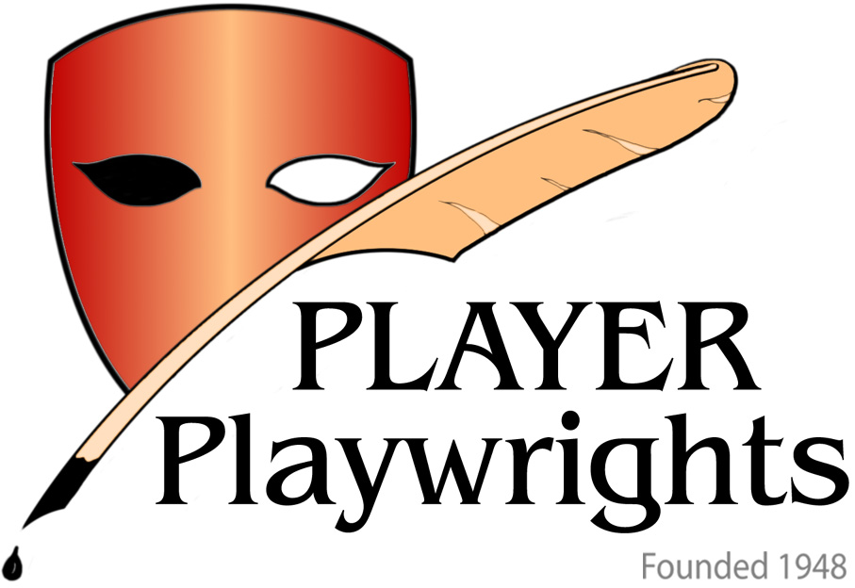

Player-Playwrights is a society of actors and writers. Its stated aims are “to encourage the writing of plays by its Members, by providing an opportunity for such plays to be presented and criticized by the Society; to widen the knowledge of all aspects of Playwriting, by inviting to its meetings Speakers and Lecturers on Dramatic Theory and ... to explore all avenues whereby members’ work may be presented to the Public” (Constitution 10/08/1948). We meet from about 7.30pm every Monday (except holidays) to hear/see/read/perform/discuss scripts submitted by members. Our venue is the room upstairs at the Horse and Groom, 128 Great Portland St W1 (near Broadcasting House). Visitors are always welcome.

Our membership includes established writers and actors as well as newcomers. Our overall aim is to enable the author with a script for stage, radio, cinema or TV to have it presented professionally (by our actor members) and discussed.

It costs £10 to join and £6 a year after that, the first £6 being due on the New Year’s Day after joining. There is also an attendance fee of £2 for every Monday meeting attended; this charge is collected on the night from members and visitors alike. For more information telephone Peter Thompson on 020 8883 0371 [or ring his bell at No 9 Hillfield Park] or send an email to P-P@dial.pipex.com or visit our website: http://groups.msn.com/PlayerPlaywrights.

