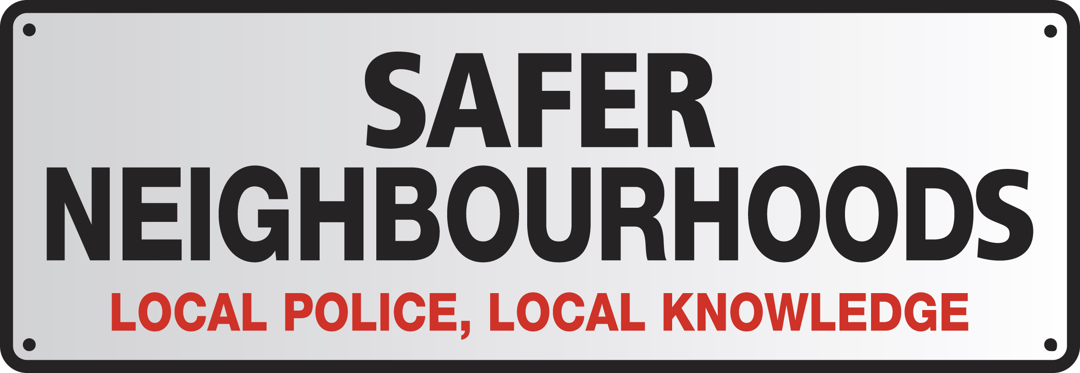
London Borough of Haringey

Muswell Hill Team
0208 721 2765 or 07760170127

MuswellHill.SNT@met.police.uk
In an emergency please call 999

News from your local police December 08

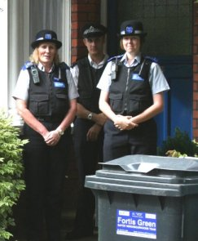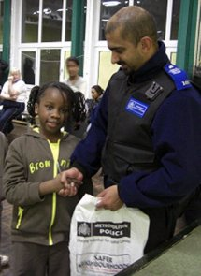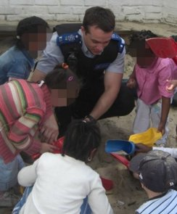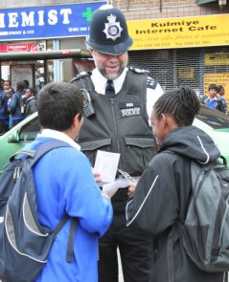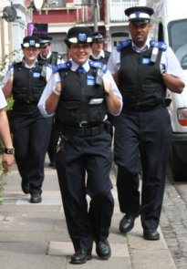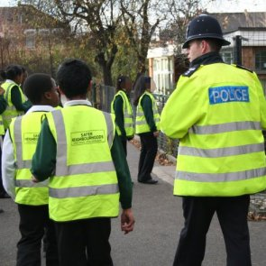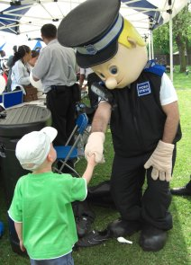

Welcome
Greetings Ladies & Gents,

Well the festive season has come to an end and reluctantly we are beginning to get back into the work thing. The first task I had was to try and find a pair of trousers big enough to get round my bulging waistline.

Hopefully new year’s eve went off well for you, I can’t comment because I was in the thick of it…Trafalgar Square!

Well, I’m pleased to tell you that there isn’t a great deal to tell you, if that makes sense. The ward has been fairly quiet over the holiday period. I’ve checked the crime stats and they back this up.

One thing to mention though that does rear it’s ugly head at this time of year is distraction burglary. This normally takes the form of people pretending to be from the water board, which, of course no longer exists. They usually state that there has been a burst pipe and will need to access your property in order to repair it. So, in light of this I have listed below some precautionary action you can take with any unknown callers to your property.

When you hear someone at the door:
- Take your time - a genuine caller will wait
- Look and see who is there, using the door viewer or a window
If you do not recognise who it is:
- Apply your door chain or door bar
- Check all your doors are locked - burglars often come in pairs, so one may come in the back whilst you're being distracted at the front door

Always ask for identification, but remember:
- ID cards are easy to copy. If in doubt, ask them to wait and call their company to check - once again, a genuine caller will not mind
- Use your phone book or utility bill to find the number - don't accept a mobile number offered to you by the caller
- Utility companies don’t normally call without prior appointment. If they say it’s an emergency ask them to get a Police Officer to attend.
You do not have to let people in and if you are uncertain then don't, however persuasive or plausible the caller is. It is better that a genuine caller is turned away than a burglar is let in.
And if you look after someone who is elderly or vulnerable, please do all you can to make sure they heed this advice - and to persuade them not to keep large sums of money at home.
If in doubt keep them out!

A timely reminder that your local safer neighbourhood team work to a set shift and you may find that when you call during the week we may not be on duty. If you wish to speak to police for any reason that is non-emergency then you will want to take a note of this number, which is also easy to remember: 0300 123 1212.

So, onto other things and here is an update of our priorities.

No.1 Theft from Motor Vehicles
The month of December saw car crime reduce to single figures across the ward. This is a welcome reduction but we will continue to press home the importance of keeping valuables out of sight. As I mentioned last month we still often see sat navs, money and even mobile phones left in unattended vehicles. Most car crime is opportunistic so we encourage you all to take precautions in preventing you from becoming a victim.
No.2 Burglary

There were 5 reported incidents of Burglary dwelling across the ward for this month. This figure continues to decrease but as I mentioned earlier we do see an increase in distraction burglaries at this time of year. Also, hopefully by now all those empty boxes outside your house have been dumped, you know the ones that have been advertising the fact that have some new and expensive items. If you have not as yet, please ensure you dispose of them at the local tip as soon as you can.

No.3 Robbery/Pickpocket
Robbery had dropped off dramatically with no reported crimes for December. Pickpocket has 2 reported crimes for December in the Broadway so, stay vigilant when out shopping especially in busy stores.

Other Matters.

We will be holding a police surgery next month, the venue as yet is undecided but will be local to the Broadway. It will give residents an opportunity to talk to us in an informal environment about any concerns or issues they have. We will circulate the date and place in due course.

Don’t take my word for it!
If you would like to view crime levels for your area or road where you live, paste the link below into your web browser. It’s easy to navigate and very informative. To use, simply load the page and you’ll see a menu on the left headed ‘Related Links’. Underneath this you will see a link headed ‘Detailed Crime Figures’, click on this to see ward based breakdowns etc.
http://maps.met.police.uk

Your Safer Neighbourhoods Team is not a 24-hour emergency response team. In an emergency always dial 999.
Find prevention advice, report crime and learn more about the work of Safer Neighbourhoods teams in your borough by visiting www.met.police.uk/haringey
You can give information anonymously to Crimestoppers on 0800 555 111

Met Volunteers Programme

Working as a Met Volunteer is a great way of meeting people and putting a little bit of time to good use so if you or someone you know can help us then please give Zobaida a call to find out more about becoming a Met Volunteer.

Your Team
Sgt Paul Davies PCSO Emma Martin
PC Paul Lancaster PCSO Vikki Webster
PC Allan Greig PCSO Cathy Tucker

